Game Design Document

Fill up the following document

1. Write the title of your project.

Catching butterflies

1. What is the goal of the game?

To catch maximum butterflies

1. Write a brief story of your game.

A girl is very fascinated of butterflies, so she goes in a garden which is full of butterflies and is trying to catch butterflies

1. Which are the playing characters of this game?

* Playing characters are the ones who respond to the user based on the input from the user.
* Cars, monkeys, dinos, wizards, etc., are the playing characters in the game.

|  |  |  |
| --- | --- | --- |
| Number | Character Name | What can this character do? |
| 1 | girl | She is trying to cathch butterflies. |
| 2 |  |  |
| 3 |  |  |
| 4 |  |  |
| 5 |  |  |
| 6 |  |  |
| 7 |  |  |
| 8 |  |  |

1. Which are the Non-Playing Characters of this game?

* Non-Playing characters are the ones that don't have an action or behavior when the user interacts with the game.
* Hurdles, stones, bananas, coins, etc., are non-playing characters in the game.

|  |  |  |
| --- | --- | --- |
| Number | Character Name | What can this character do? |
| 1 | stone | They are the obstacles in the game |
| 2 | butterflies | When we catch them we gain points. |
| 3 |  |  |
| 4 |  |  |
| 5 |  |  |
| 6 |  |  |
| 7 |  |  |
| 8 |  |  |

Draw your imagination of this game. What does this game look like?

* Draw the game either on your computer or on paper.
* Add images of the game scenes to show each of the playing and non-playing characters at least once.

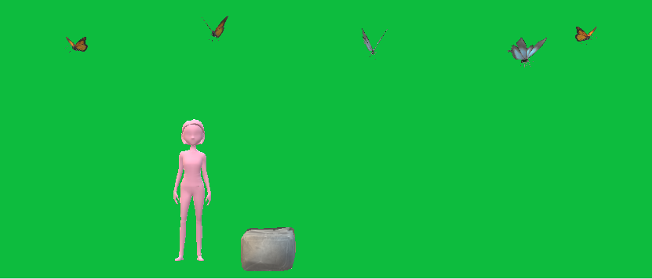

How do you plan to make your game engaging?

I have obstacles in my game which will not make the game a bore. I have points which will encourage players to play the game.

I will make my project using VS Code.